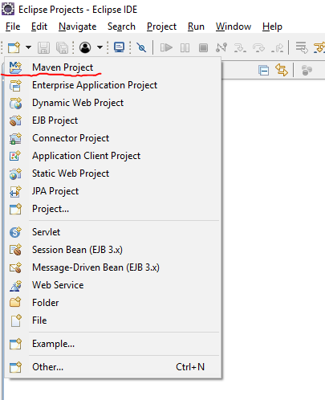

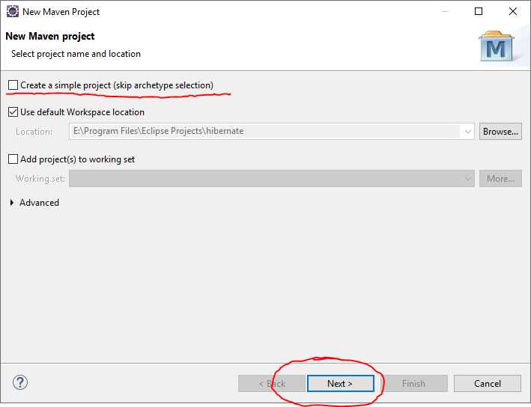

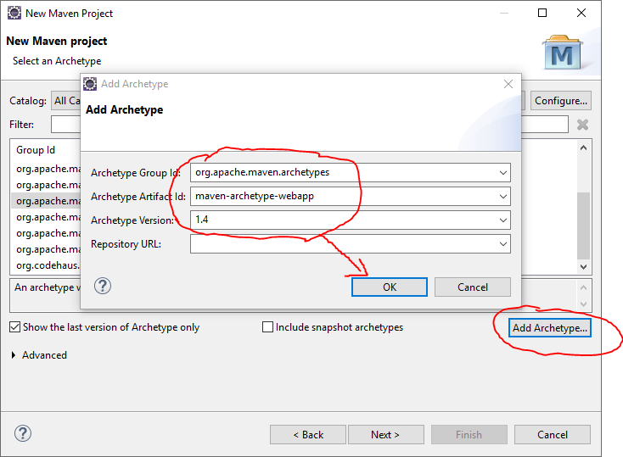

org.apache.maven.archetypes

maven-archetype-webapp

1.4

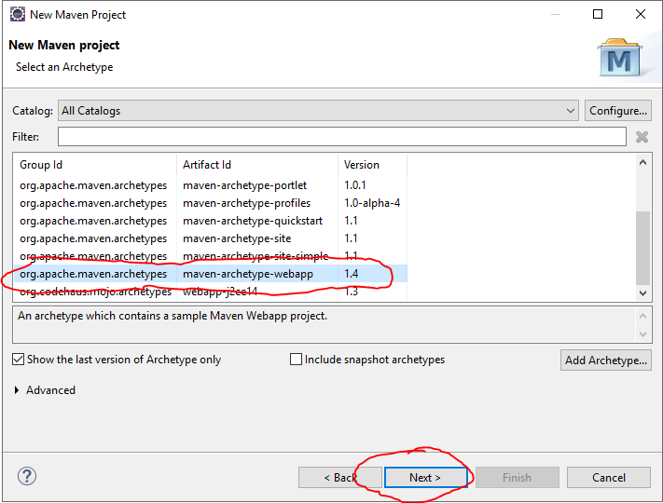

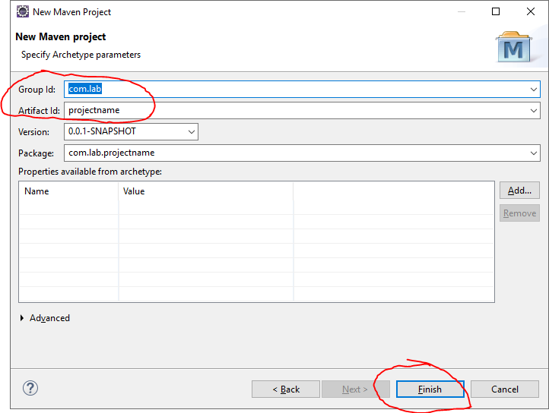

**If you want to use JSTL (for example <c:forEach>) in your JSP, you have to upgrade web.xml file like this:**

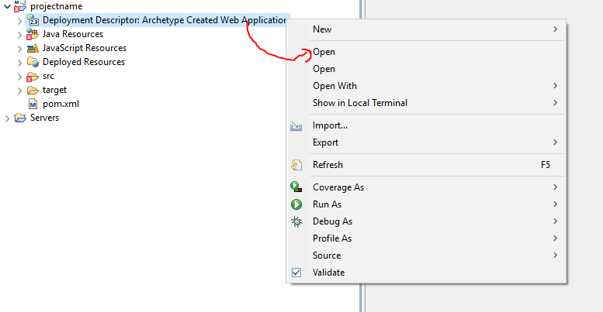

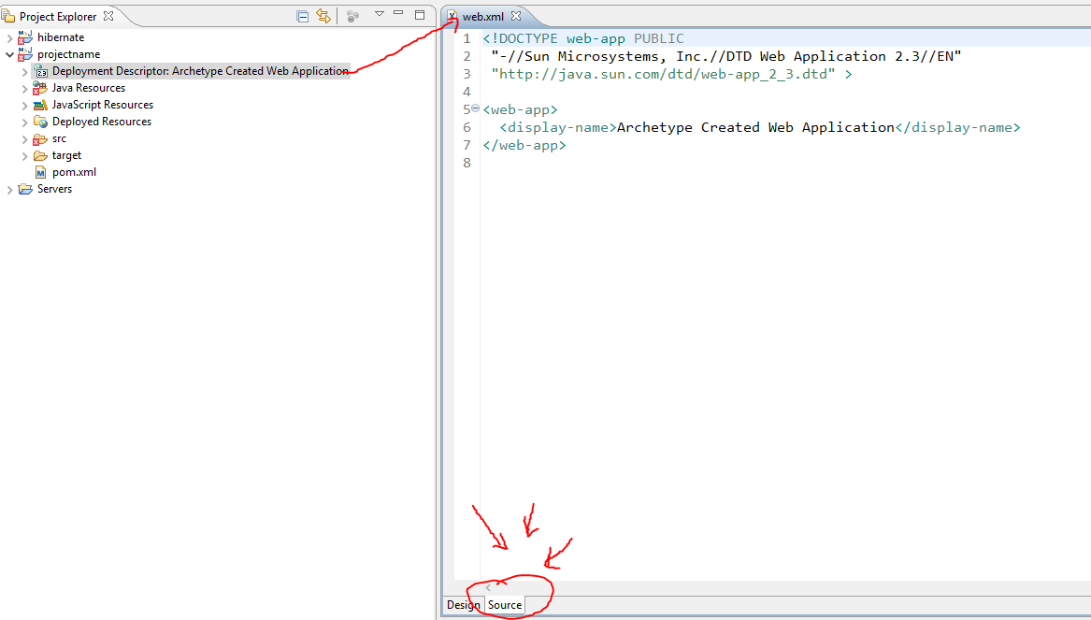

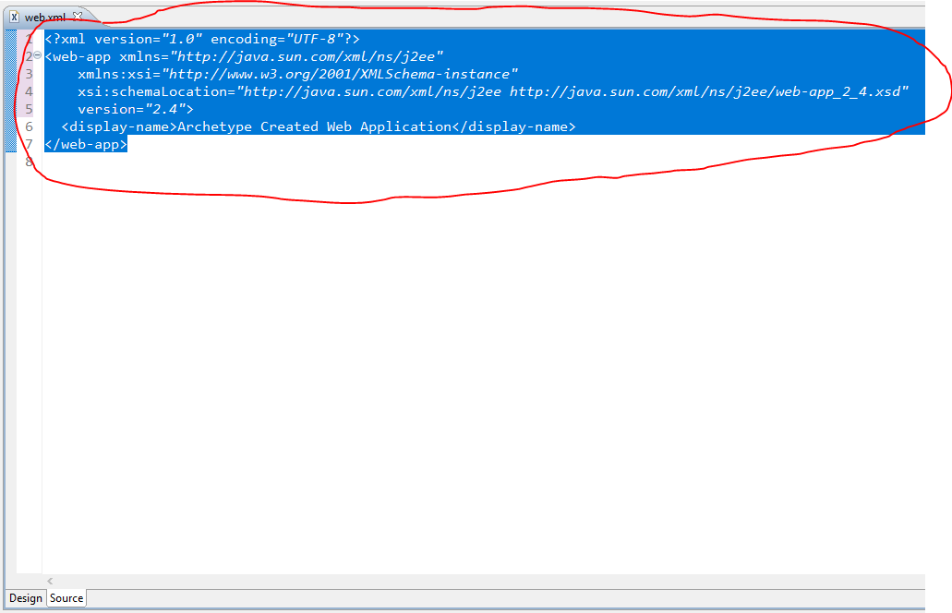

<?xml version=*"1.0"* encoding=*"UTF-8"*?>

<web-app xmlns=*"http://java.sun.com/xml/ns/j2ee"*

xmlns:xsi=*"http://www.w3.org/2001/XMLSchema-instance"*

xsi:schemaLocation=*"http://java.sun.com/xml/ns/j2ee http://java.sun.com/xml/ns/j2ee/web-app_2_4.xsd"*

version=*"2.4"*>

<display-name>Archetype Created Web Application</display-name>

</web-app>

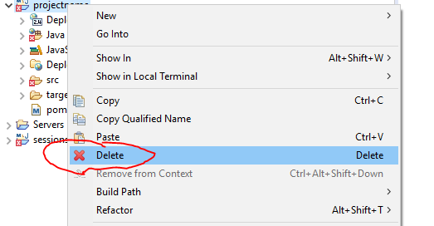

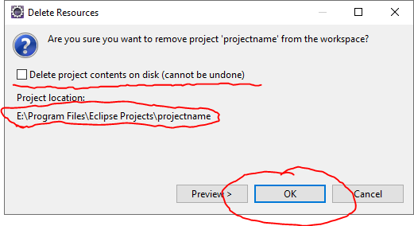

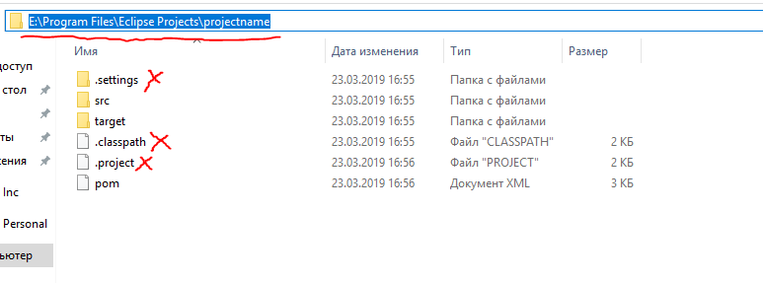

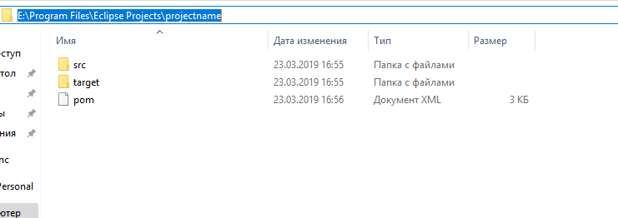

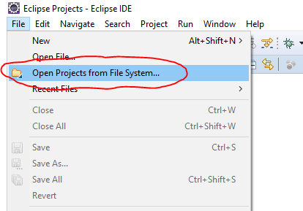

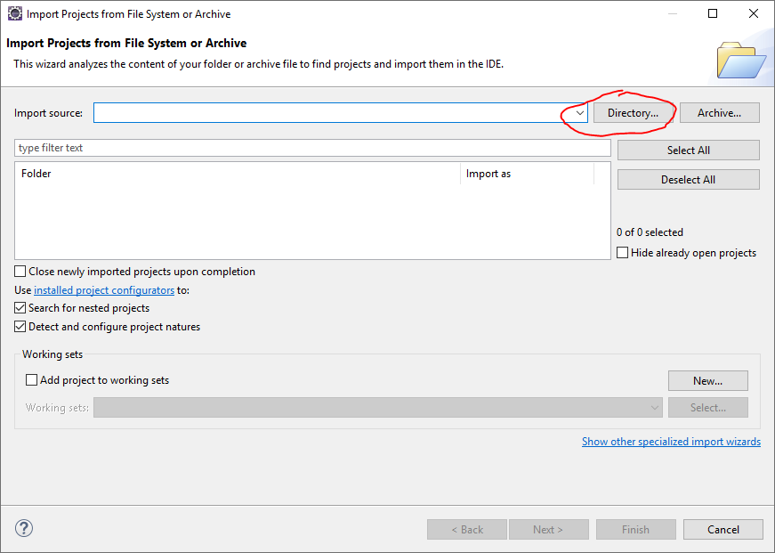

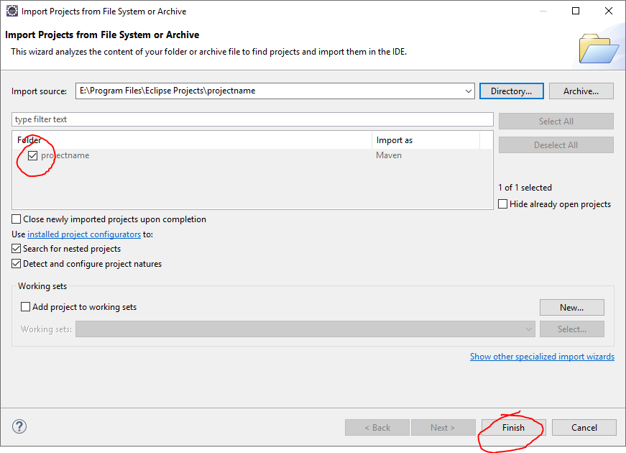

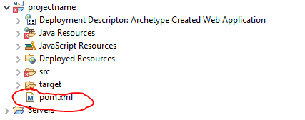

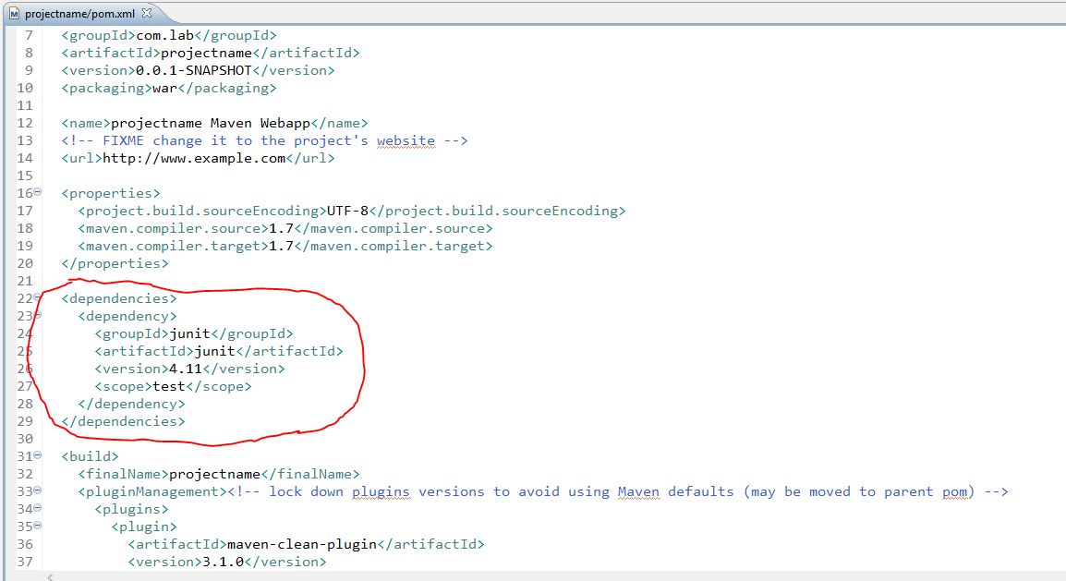

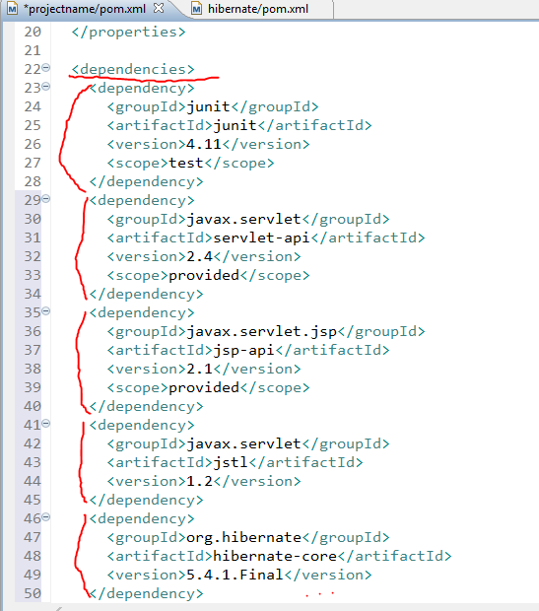

<dependency>

<groupId>javax.servlet</groupId>

<artifactId>servlet-api</artifactId>

<version>2.4</version>

<scope>provided</scope>

</dependency>

<dependency>

<groupId>javax.servlet.jsp</groupId>

<artifactId>jsp-api</artifactId>

<version>2.1</version>

<scope>provided</scope>

</dependency>

<dependency>

<groupId>javax.servlet</groupId>

<artifactId>jstl</artifactId>

<version>1.2</version>

</dependency>

<dependency>

<groupId>org.hibernate</groupId>

<artifactId>hibernate-core</artifactId>

<version>5.4.1.Final</version>

</dependency>

<dependency>

<groupId>org.xerial</groupId>

<artifactId>sqlite-jdbc</artifactId>

<version>3.25.2</version>

</dependency>

<dependency>

<groupId>com.github.gwenn</groupId>

<artifactId>sqlite-dialect</artifactId>

<version>0.1.0</version>

</dependency>

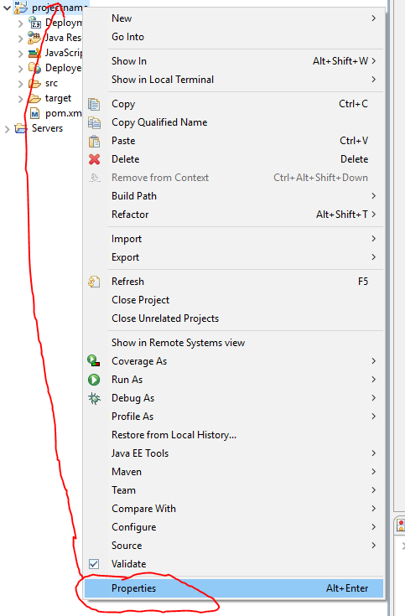

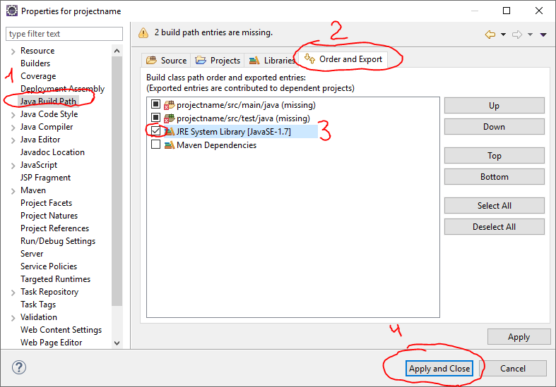

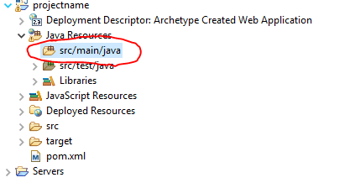

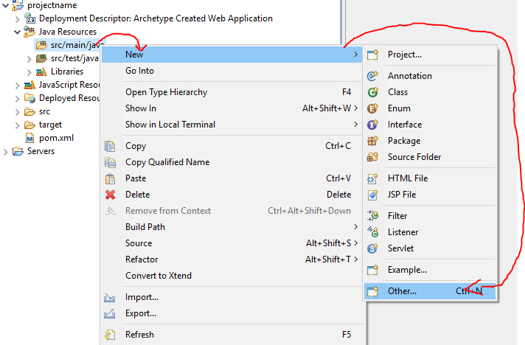

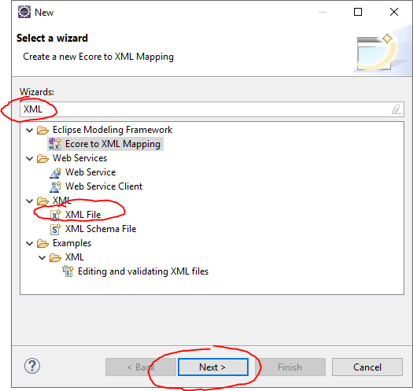

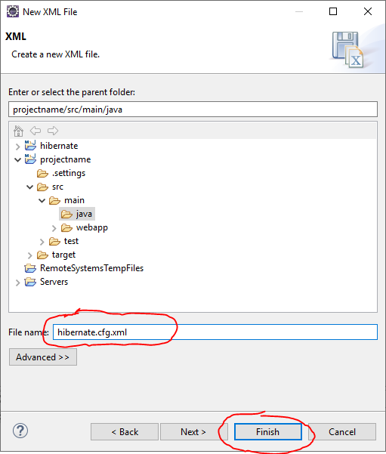

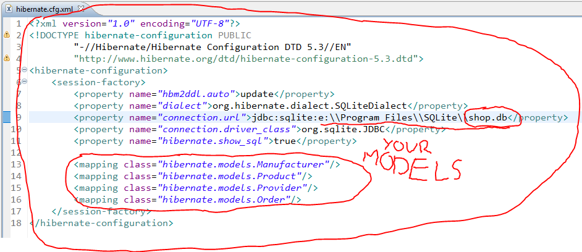

<?xml version=*"1.0"* encoding=*"UTF-8"*?>

<!DOCTYPE hibernate-configuration PUBLIC

"-//Hibernate/Hibernate Configuration DTD 5.3//EN"

"http://www.hibernate.org/dtd/hibernate-configuration-5.3.dtd">

<hibernate-configuration>

<session-factory>

<property name=*"hbm2ddl.auto"*>update</property>

<property name=*"dialect"*>org.hibernate.dialect.SQLiteDialect</property>

<property name=*"connection.url"*>jdbc:sqlite:e:\\Program Files\\SQLite\\shop.db</property>

<property name=*"connection.driver_class"*>org.sqlite.JDBC</property>

<property name=*"hibernate.show_sql"*>true</property>

</session-factory>

</hibernate-configuration>

